

PETROVA |  |  |  |  |  |  |  | 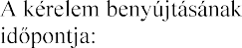  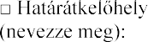  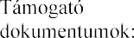  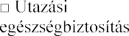
IVANOVA
MARIIA
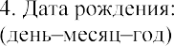  20-04-1990 |  | SELO PETUSHKI  Строго по паспорту РФ  USSR |  |  |  | 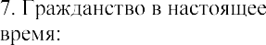  RUS USSR
 |  |  | 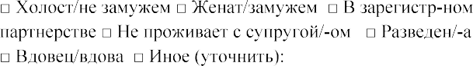
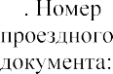  73 0000000 | 27-04-2018 |  |  | 27-04-2028 |  |  | ROSSIA
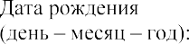 |  |  |  |  | 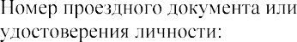

SVERDLOVSKAYA OBLAST, EKATERINBURG, GAGARINA 10-100, VISA.JKB@MFA.GOV.HU |  | +7-9221509044
ROSSIA
MANAGER
OOO "KONSULSTVO", SVERDLOVSKAYA OBLAST, EKATERINBURG, FROLOVA 5, TEL.
+7(343)355-92-54
VENGRIA | CHEKHIA

03-03-2020

10-03-2020

10-02-2019
000000000
DANUBIUS HOTEL MARGITSZIGET
1007 BUDAPEST, MARGITSZIGET |  | 36-1-889-9999
 |  | 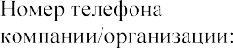
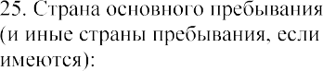
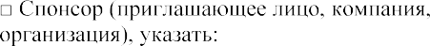

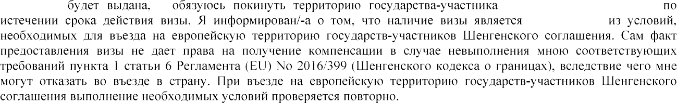

EKATERINBURG 03-02-2020

